**For BOW**:

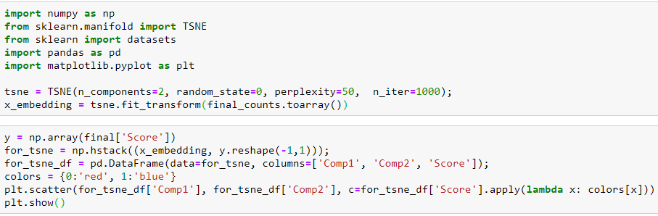

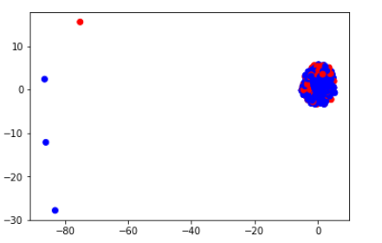

**For bigram:**

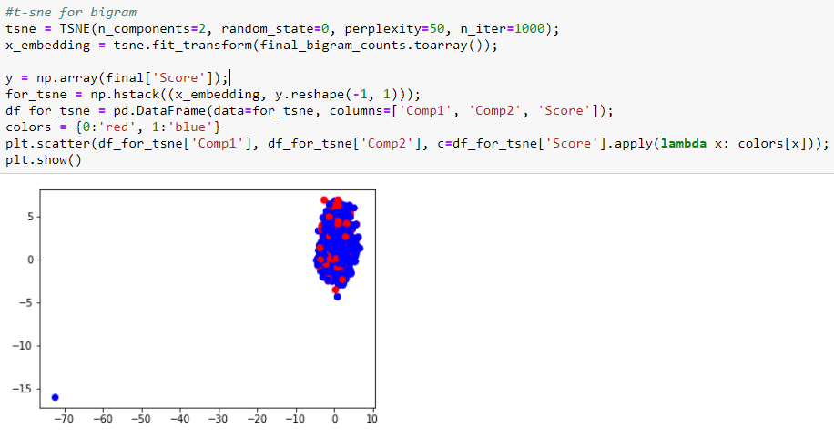

**3 ) t-sne for tf-idf**

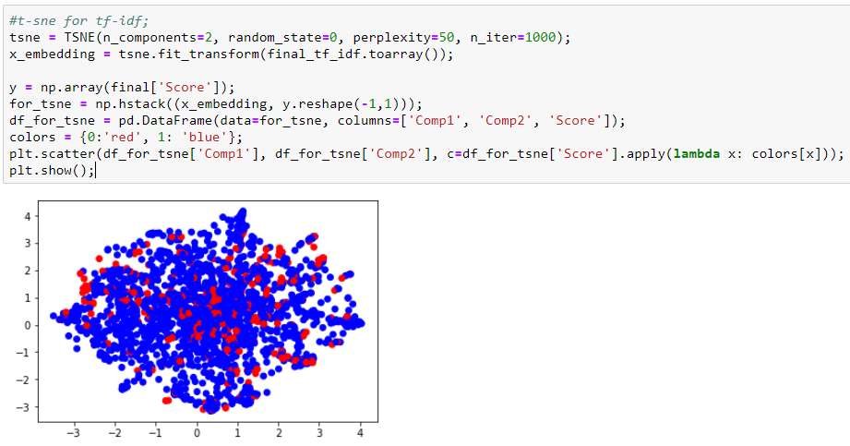

**4 ) t-sne for avg w2v**

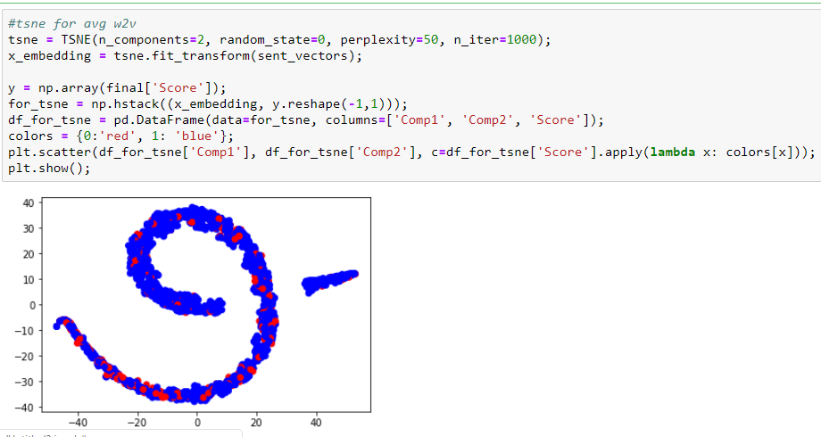

**5 ) t-sne for text tfidf weighted w2v vectors**

